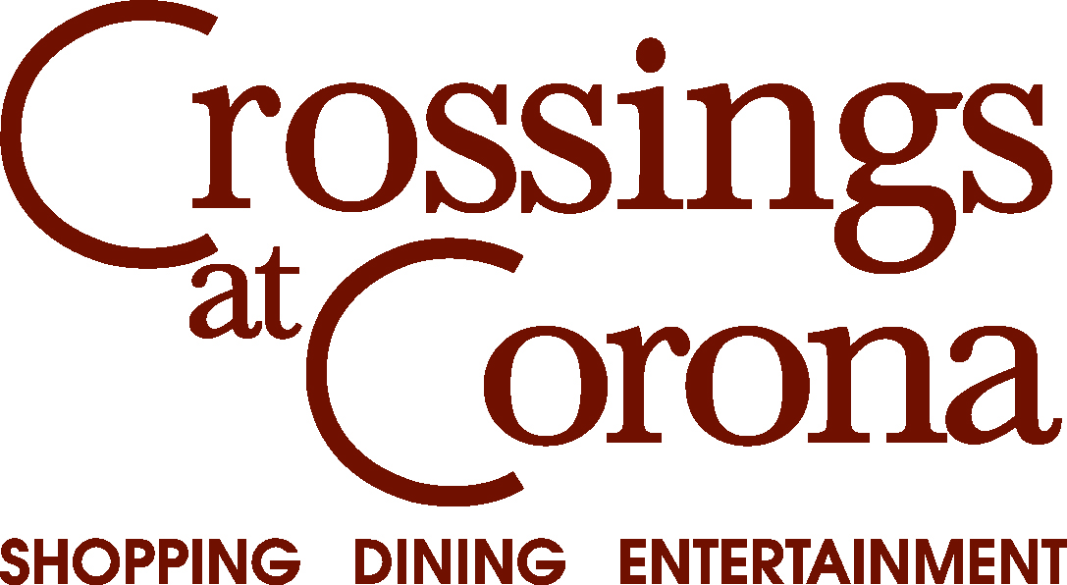

2013 CROSSINGS OnSTAGE

TALENT SHOW PARTICIPANT INFORMATION

Name:____________________________________________________
Contact Phone Number:______________________________________
Email Address:_____________________________________________

PERFORMANCE DETAILS:

Please describe your performance:_____________________________________________________________________________________________________________________________________________________________________________________________________________________________________________________________________________________________________________________________________________________

Number of people in your performance:_______
Number of microphones required:_______
Length of your performance (in minutes):_______

Note: We will provide sound system and microphone. Bring your own music track on cd if applicable. Stage size is 24X16.

EVENT DAY DETAILS:
Event date: Friday, September 20
Event Location: Crossings at Corona, near Edwards Theater (by large fountain)
Check in at 4:30pm at the Main Stage located near the large fountain in front of Edwards Theater. At time of check-in, provide your music track with your name clearly printed on the label.

Thank you for your participation in Crossings OnStage! If you have any questions, please email Kelly Shirey at kelly@tvpinc.net.

