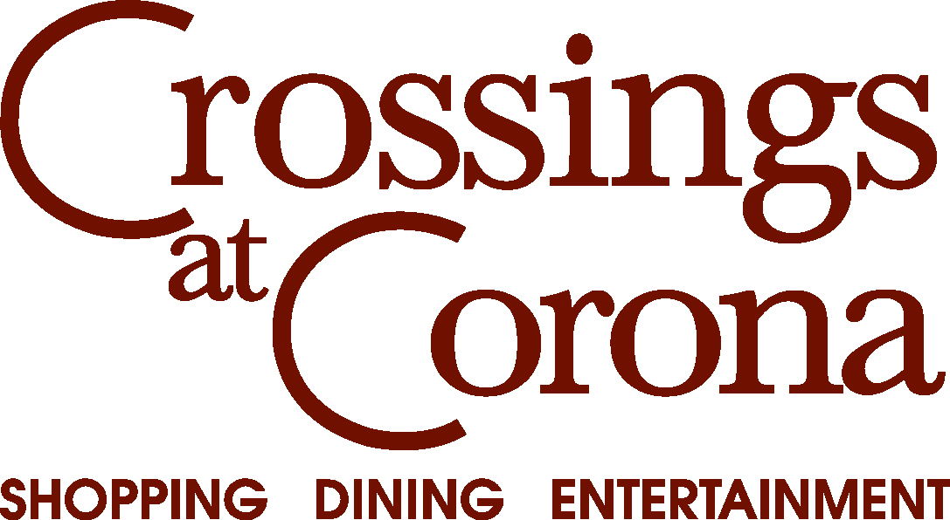

Fashion Show Models Needed!

Crossings at Corona will be hosting the 5th Annual Crossings OnStage event on Friday, May 22nd at 5pm. The event will take place near the large fountain in front of Edwards Stadium 18 Theatre.

We are looking for models, both boys and girls, no experience is needed.

We are looking for models from grades 1st-12th. You must pre-register by, May 5th by emailing: DeGraveCom@gmail.com. Please note this is on a first come, first serve basis.

Thank you very much! We are looking forward to another successful event at Crossings at Corona!

